Maths

**We will be learning about:**

Functional Skills.

Topic - Number

Students work towards EL1, EL2 and EL3 -level depending on their current assessment.

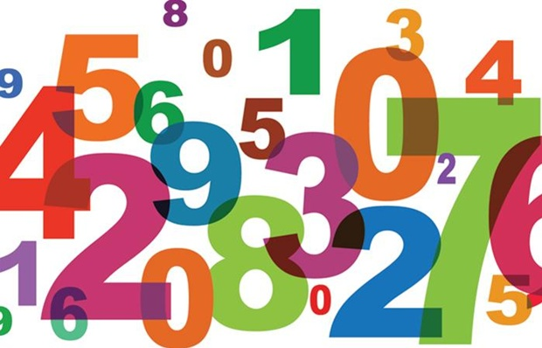

Personal & Social Development

(E2) Adapting to New Situations

**Explore personal feelings about new situations:** To contribute to discussions about new situations experienced**.** To contribute to discussions about feelings experienced when adapting to new situations

**Demonstrate skills in adapting to new situations.**

**(E1) Engaging in New Situations;** Participate in new situations, with support:

To contribute to preparing to participate in new situations

To participate in new situations with the support of others

To communicate with others about own experiences in new situation

**10H Curriculum Leaflet**

**Autumn 1**

**Form tutor:** Mr. Hajdrych

**Teaching assistants:** Mr. Lambkin

Tutor Time Focus:

Communication within the group

Self-regulation

Preparations for assemblies

Cirlce Time (discussing relevant/ current events)

SSC Class Meetings

History/Geography

**We will be learning about:**

WJEC Unit - Tectonic Events

Under Our Feet – The Structure of the Earth

Volcanoes – How they are caused and how they impact

Earthquakes – How they are caused and how they impact

Tsunamis – How they are caused and how they impact

Computing

**We will be learning about:**

Preparation for OCR Entry Level 1-3

Developing range of skills in Office 365.

Students will understand requirements of Entry Level Tasks.

Science

**We will be learning about:**

Biology ELC:

Cells

Organ systems

Air exchange and respiration

Lifestyle choices

How our body fights infection

Nerves

Hormones

English

**We will be learning about:**

Introduction to Entry level qualifications in English, including acquiring an understanding of everyday words and their uses and effects, reading texts encountered in everyday life and work and to begin to write independently with nonfiction text types.

DT/FT

**We will be making:**

Decorative wooden glasses holders

**We will be learning to:**

Use tools safely in the workshop

Plan, create, and evaluate our own designs

PfA

* Reading for 20mins every day (independently or with an adult)
* Complete an A4 tonal pencil drawing of a natural form
* Create a collage out leaves you find
* Go for a walk with your family and draw 4 things you see on your walk
* Make your own natural sculpture in the garden or at the park one weekend – take a photograph of it and bring it in/email it to your teacher
* Visit an art gallery with your family or visit the website of an art gallery if you cant actually go. Find 2 artists work you really like and write down their names. Draw a picture of their artworks and explain what you like about them.
* Carry out your own research into an artists you like. Make a poster about them.

‘Preparing for Adulthood’ – an introduction to PfA lessons, PfA – Student Aspirations: ‘My Future Will Look Like This’

‘Routines & Responsibilities at Home & at School’, Preparation for PCARs

Preparation for PCARs, Practise sharing the information for my PCAR meeting.

Beginning Year 10 PCARs

Events this half term

Home Learning Opportunities

Music

**We will be learning about:**

**Practical Music making:**

Experimenting and creating: Composing music within given musical structures

Playing

Creating and refining our own compositions.

**Music Technology:**

Manipulating sound using digital platform

Art

**We will be learning about:**

UAL Entry Level 3

Students will explore different materials and techniques to record observations. They will engage with the artwork of Andy Goldsworthy and Richard Long to create own temporary artworks on Hackney Downs. They will work of Elena Nuez and plan and paint stone linking to her work and theme of ‘Only One You

Students will create and lead a community project – whole school stone painting

PE

**We will be learning about: badminton**

To take part in badminton activities safely

Forehand

Backhand

Forehand and backhand practise.

Forehand serve.

Backhand serve.

Practical assessment of badminton skills