Remote Learning Timetable – 12H
 | Monday | Tuesday | Wednesday | Thursday | Friday
9:15 – 9:30 | Tutor Time on Teams | Tutor Time on Teams |  |  | Tutor Time on Teams
9:30 – 10:30 | Live Lesson – PfA with Mr. Hajdrych | Live Lesson – English with Ms. Burke |  |  | Activity menu
10:30 – 11:00 | Independent Break | Independent Break |  |  | Independent Break
11:00 –12:00 | Activity menu | Activity menu |  |  | Activity menu
12:00 – 13:00 | Lunch | Lunch |  |  | Lunch
13:00 – 13:30 | Joe Wicks PE | Dance with Oti |  |  | Joe Wicks PE
13:30 – 14:30 | Activity menu | Live lesson – Maths with Mr. Giltay |  |  | Live lesson – Workskills with Ms. McKell
14:30 – 15:00 | Tutor Time on Teams | Tutor Time on Teams |  |  | Tutor Time on Teams
After school | Optional Activities | Optional Activities |  |  | Optional Activities

Live lessons include live teaching from subject teacher, follow up tasks, and support from class TA
Independent break is a time that your child can study without direct supervision from you eg. cut up some fruit to eat, do some physical movement to music, go outside and do 20 star jumps, 20 lunges and 20 deep breaths.
Activity menu means you can choose from the following:
- Independent/guided reading
- Online resources as directed by your teacher (Oak National Academy, BBC Bitesize, Mathletics, Nessy, Bedrock),
- Paper-based work from home learning pack
- Teams Assignments set by your subject teachers
At lunch time learners can help prepare lunch, lay the table, and wash up
PE with Joe Wicks: https://www.youtube.com/channel/UCAxW1XT0iEJo0TYlRfn6rYQ
Dance with Oti: https://www.youtube.com/channel/UC58aowNEXHHnflR_5YTtP4g
Cook along with Tom: https://www.hackneyschooloffood.com/
Optional Activities: Reading, handwriting practice, drawing, practising singing/dancing/an instrument

Daily Reading
It is recommended that your child reads at least once every day at a time that suits your family. This can take the form of reading independently, or with an adult family member/older sibling. Your child could read from a book sent by their class teacher, a text set by the teacher online, or any other text they are interested in; a book from home, something on a kindle, a magazine or comic, even reading the ingredients on the back of the cereal box counts! The main thing is that your child reads with TRUST.
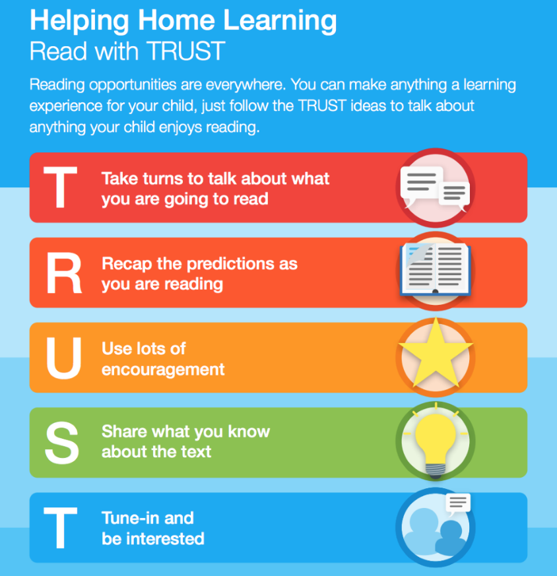

PfA lessons
'PfA' stands for Preparing for Adulthood and the lessons are based on the four PfA outcomes; Friends, relationships, and community; Health; Independent living; Employment. The lessons are usually taught by the form tutor, and the outcomes form part of Annual Reviews from Year 9 onwards.

