

**Stormont House School Matters**

Our vision

Achievement for all in a unique world-class school

Stormont House School, Downs Park Road, London E5 8NP. Tel No (020) 8985 4245

Website: [www.stormonthouse.hackney.sch.uk](http://www.stormonthouse.hackney.sch.uk) Email: [info@stormonthouse.hackney.sch.uk](mailto:info@stormonthouse.hackney.sch.uk)

Twitter:

Week ending 01/10/21

The Journey starts here….





Congratulations to our Sixth Formers who started college last week. The tutors were very impressed with their focus, confidence, and readiness to learn. In particular DJ, Ryan, Tallulah and AJ made an outstanding start at BSix. We are so proud of the great start our students have made so quickly this term.

Sixth Form Students of the Week:

Zak for being so helpful with supporting other students

Ryan for his enthusiasm and hard work both at Stormont and BSix

DJ for his work with Young Hackney

**Sports/PE Kit:**

* Plain white tee shirt
* Plain black shorts
* Plain black or grey jogging trousers
* Trainers
* Optional tracksuit (plain black or grey)

**Uniform:**

* Dark grey school skirt or dark grey school trousers
* Plain white school shirt or plain white polo shirt
* Dark green (bottle green) sweatshirt with school logo or Dark green (bottle green) school v neck cotton jumper with school logo. No hooded sweatshirts – students will be asked to remove them
* Plain black school shoes (no trainers except for PE)
* A suitable outdoor coat which must be removed in lessons and assemblies
* Religious clothing e.g., headscarves and salwar kameez must be plain black

School Uniform and PE Kit

School uniform can be purchased online at – [myclothing.com](https://myclothing.com/)

The School Garden

The school garden harvest from this summer was donated to the Akwaaba centre in Hackney. All 100% organic and 100% grown by Stormont House Environmental Studies students.

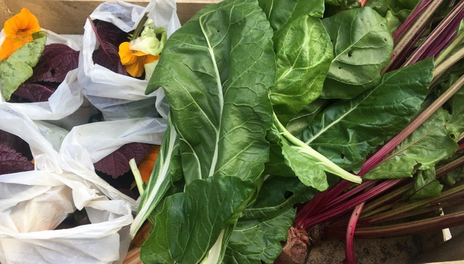

Flu Vaccination Programme (Yrs 7-12) – Thursday 14 October

- Year 11 6th Form Information Evening (virtual) – Thursday 14 October

- Students break up for half term – Friday 22 October

Further details about this to follow along with a parental consent form early next week.

Please be reassured that students will not be vaccinated unless we have parental consent. If we do not have consent your child will not be vaccinated.

COVID-19 Vaccinations in School for Students age 12+



Welcome to a new academic year at Stormont House. We are writing with information about the Speech and Language Therapy (SaLT) team working at Stormont this year. The therapist’s working at Stormont House are:

Speech and Language Therapy Team

**Leah Hood**

Link classes: 7MA, 9N, 10A, 12M, 12W

**Sophie Lewis**

Link classes: 7MU, 8G, 10M, 9E, 11B

**Jenny Marcall**

Link classes: 8G, 11G, 12W



