PfA

**We will be learning about:**

PfA – Student Aspirations:

‘My Future Will Look Like This’

‘Routines & Responsibilities at Home & at School’

Preparation for PCARs

**11M Curriculum Leaflet**

**Autumn 1**

**Form tutor:** Mr. Mole

**Teaching assistants**: Mr. Ramphul

Tutor Time Focus:

Y11 students as role models

Getting ready for college

Exams

History

**We will be learning about:**

The British Empire, Trade and Revolution.

Computing

**We will be learning about:**

Preparing for Entry Level 1-3 Functional Skills in ICT task- taking.

Developing skills in Office 365 and understanding the requirements of the different Entry Level Tasks.

Personal & Social Development

**We will be learning about:**

BTEC Unit 9:

Developing Digital Skills. We will use a range of devices and applications to build IT skills.

Science

**We will be learning about:** Biology – The Human Body

What the body is made of – Cells, Specialised cells, tissues, organs and organ systems.

The digestive System and Circulatory system.

Respiration and how the lungs work

Lifestyle and keeping the body and our organs healthy –the benefits of exercise, diet, and what happens if we have an unhealthy lifestyle.

Maths

**We will be learning about:**

How to use numbers (counting, operators, and rounding) at Entry Level 1 to Entry Level 3 Functional Skills.

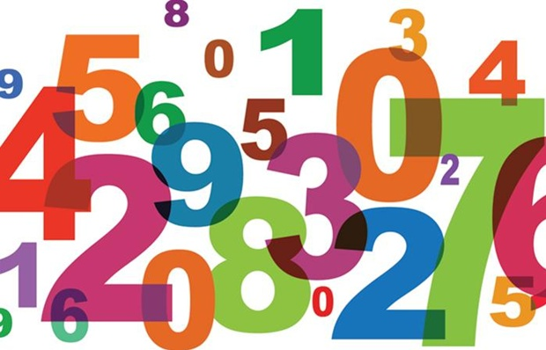

English

**We will be learning about:**

Exploring the creative writing elements of Step Up to English modules, as well developing technical accuracy and comprehension for functional skills assessments.

Reading, understanding, and writing a Gothic Horror Story.

* Re-reading and re-telling chapters of the text at home to consolidate comprehension.
* Reading 20 mins per day (independently or with an adult)
* Writing a Gothic story
* Creating a gothic character
* Carry out responsibilities at home; take selfies/ photos as evidence.
* Practise presenting for their PCAR presentation.
* Students could join a local sports club where they can play basketball. They could also research the rules of basketball.
* Find an image of a famous building in London (e.g., the shard, Big Ben or the London Eye) spend at least 45minutes doing a careful A4 tonal pencil drawing from the image. Do not use colour.
* Find a shell or an image of a shell and do a really careful drawing of it on A4 paper – use lots of tone and texture. No colour
* Make an origami structure. Follow the instructions <https://www.wikihow.com/Make-an-Origami-Diamond>.
* Find out about the Fibonacci sequence - create a PowerPoint explaining what the Fibonacci sequence is and give examples of it in nature.
* Create your own sculpture at home https://www.tate.org.uk/kids/make/sculpture/make-paper-sculpture and bring in.

Beginning of PCARs for Year 11 students

Events this half term

Home Learning Opportunities

DT/FT

**We will be working:**

On AQA Level ½ Unit Awards

**We will be learning to:**

Make wooden bat boxes.

Design, plan, make, record and finish products following high standards of Health and Safety regulations and practice in the classroom.

Music

**We will be learning about:**

**Practical music making**

Listening to diverse musical styles, practising and composing an original piece of music. Playing a tuned instrument keyboard/xylophone. Reading and playing music from notation

**Music Technology:**

Developing soundtracks and manipulating sound using a digital platform

Art

**We will be learning about:**

Structures and 3D Artists as part of the GCSE/UAL level 2 Award.



PE

**We will be learning about:**

Basketball: health and safety in PE and basic ball handling, dribbling, catching/passing, Set shot and lay up shots.

