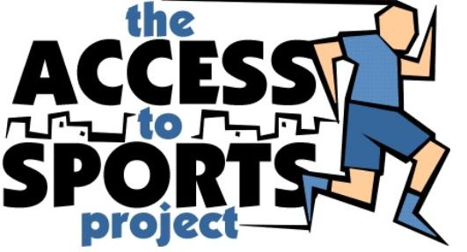
The Access to Sports Project
Membership Form 2017

Personal Details

Forename ______________________________________ Surname__________________________________________ Gender: Male Female

Address _________________________________________________________________________________________________________________________

________________________________________________________________________________________________________________________________

Postcode ______________________________________ Date of Birth _____________________Ethnicity________________________________________

Mobile _______________________________________________________ Home_____________________________________________________________

Email __________________________________________________________________________________________________________________________

Signed:
(Parent/ Guardian) ______________________________________________________________________________________________________________

Date________________________

(Please let us know whether your child will be picked up or allowed to go home alone after the session) Picked up Home alone

Participants may on occasions be photographed for media and promotional purpose. Please tick the box if you do not wish photographs of your child to be used in this way.

Medical Details
Physical Impairment Hearing Impairment
Please tick relevant boxes.

Medical Details

 | Physical Impairment |  | Hearing Impairment
 | Learning Difficulties |  | Visual Impairment
Other please state:________________________________________________________________________________________________

____________________________________________________________________________________________________

Special Requirements :
Unfortunately we are unable to assist with any child changing during the course.
(Please give details)

Please note: If your child requires emergency medication e.g. insulin to be administrated whilst at the coaching sessions please
ensure that you attend with your child on the first session to talk to the coaches.

Data Protection
As part of our work we are required to keep basic information on participants (name, address, date of birth, gender, ethnicity) in instances this information will be shared with our partners (e.g youth and leisure departments in Hackney, Islington and Haringey. For more information contact The Access to Sports Office.

Research, Monitoring and Evaluation
I acknowledge that The Access to Sports Project may undertake research questionnaire, monitoring and evaluation exercises involving child / children to measure the effectives of our work. Involvement in these activities will be purely voluntary and participants can pull out of the research at any time. I agree to contact The Access to Sports Project office should I disagree with this activity.

Occasionally we mail information on sports course etc which we believe will be of interest to our customers. Please tick the box if you do not wish to receive such information [ ].

