**7Ma Curriculum Leaflet**

**Summer**

**Form tutor:** Mr Maguire

**Teaching assistants:**   
Ms. Gould, Ms. Ali

Tutor Time Focus:

We will be using tutor time to develop out social interaction skills, such as taking turns and playing as part of a team.

Religious Education

**We will be learning about:**

Judaism

* The foundations of Judaism
* The main beliefs
* The religious places that are special to Jewish people
* Special festivals that are held
* The Holy Book and how it is used
* The symbols and how they are used

Computing

**We will be learning about:**

Designing to a brief

* Looking at how designs are used in the real world
* How we can identify the intention of an item or a product from its design
* Research effective designs used for items such as book covers.
* Design an item to a brief

Personal Social Development

**We will be learning about:**

Healthy Bodies, Healthy Minds

* What a healthy diet would look like.
* The benefits of keeping active physically and mentally
* The importance of mental health
* Personal hygiene
* The importance of shared experiences
* The importance of learning or mastering something.

Philosophy for Children

We will be learning about:

Using different books and stories to encourage the students to relate to their own life experiences. We will be engaging in whole class discussions around what the meaning of different stories could be and what lessons we could learn from them.

We will be focusing on turn taking and listening to the opinions of others in the class.

Science

**We will be learning about:**

Acids and Alkalis  
In Science this term Year 7 will be learning about Acids and Alkalis. They will be defining acids and alkalis, and identifying different acids or alkalis found in household items. They will be using the pH scale to explore the strengths of acids and alkalis and will making cabbage water to create their own PH indicator.

Maths

**We will be learning about:**

Shape  
We will be learning about the different properties of 2D and 3D shapes, such as sides, vertices, faces and edges. We will also be identifying the shapes in real world contexts and using them in patterns.

Money  
We will be learning the values of different coins and notes as well as how we use money in real life scenarios

English

**We will be learning about:**

Fantastic Mr Fox

In depth reading of Fantastic Mr Fox.

We will look at:

* Where the story is set
* The different characters
* The emotions the characters have
* What the characters are thinking
* Write a summary and a review

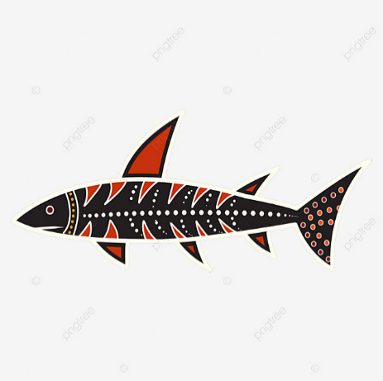

**We will be learning about**

Preparing for our PCAR  
To understand the importance of expressing our views and opinions during my Annual Review. **Annual Reviews are ongoing for Y7 this term.**

Preparing for Independent Travel  
To understand how to navigate roads safely and the pros and cons of being independemt travellers.

Preparation for Adulthood

We will be learning this term about different parts of the house as well as looking over the topics we’ve already done in Year 7!

Spanish

English – Encourage your child to read when they can. If your child is reading a book at home, ask them to bring the book in as they can be given the opportunity to read and share it with the class. Continue to use Reading Eggs and Reading Eggspress.

Maths – Encourage your child to identify some of the different properties of shapes using the correct terminology such as vertices and edges. Continue to use Mathletics.

PE – Ask your child to complete some of the exercises that they have been doing in their PE Lessons. Practice throwing and catching in the park.

Computing – Give your child the opportunity to access online resources and platforms under supervision.

If your child completes anything that they would like to share with the class, please

Home Learning Opportunities

Resistant Materials

**We will be making: A wooden salad server**

* What are the shapes and how can we draw them?
* How can the computer help us to draw shapes?
* What is a design brief?
* What is the design process?
* What makes a good salad server?
* What materials and processes can we use to make our salad server?

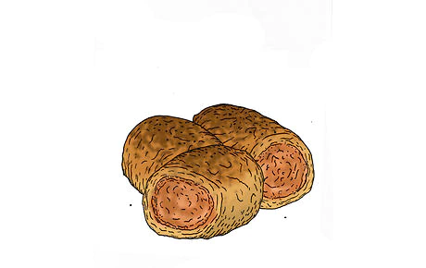

Music

**We will be learning about:**

**Singing**

* Singing in a group
* Performing confidently
* Learning a song by heart for the Hackney music festival
* Attend the Hackney music festival
* Learn songs from the musical Oliver

Art

**We will be learning about:**

**Aboriginal Art**

* Know what an aboriginal symbol is
* Design and draw a shark
* Make sharks using papier-mâché
* Paint shark using aboriginal symbols

PE

**We will be learning about:**Cricket  
- Catching and throwing the ball with control and coordination  
- To throw a ball under arm and over arm when fielding  
- To bowl using over arm and under arm throws  
- To bat with control

Tennis  
- To perform forehand/backhand throws  
- To serve overhead or underarm